Practical-10

Name:-Vishwajit Kate

Reg. No:-2020BIT011

# Practical no:10 implement the following algo.

# Dijekistra algo.

# Huffmen coding

# Write a Algorithm with complete Simulation

# 1) Dijekistra algo.

# Code:-

// 2020BIT011

#include <stdio.h>

#define INFINITY 9999

#define MAX 10

void Dijkstra(int Graph[MAX][MAX], int n, int start);

void Dijkstra(int Graph[MAX][MAX], int n, int start) {

int cost[MAX][MAX], distance[MAX], pred[MAX];

int visited[MAX], count, mindistance, nextnode, i, j;

for (i = 0; i < n; i++)

for (j = 0; j < n; j++)

if (Graph[i][j] == 0)

cost[i][j] = INFINITY;

else

cost[i][j] = Graph[i][j];

for (i = 0; i < n; i++) {

distance[i] = cost[start][i];

pred[i] = start;

visited[i] = 0;

}

distance[start] = 0;

visited[start] = 1;

count = 1;

while (count < n - 1) {

mindistance = INFINITY;

for (i = 0; i < n; i++)

if (distance[i] < mindistance && !visited[i]) {

mindistance = distance[i];

nextnode = i;

}

visited[nextnode] = 1;

for (i = 0; i < n; i++)

if (!visited[i])

if (mindistance + cost[nextnode][i] < distance[i]) {

distance[i] = mindistance + cost[nextnode][i];

pred[i] = nextnode;

}

count++;

}

for (i = 0; i < n; i++)

if (i != start) {

printf("\nDistance from source to %d: %d", i, distance[i]);

}

}

int main() {

int Graph[MAX][MAX], i, j, n, u;

n = 7;

Graph[0][0] = 0;

Graph[0][1] = 0;

Graph[0][2] = 1;

Graph[0][3] = 2;

Graph[0][4] = 0;

Graph[0][5] = 0;

Graph[0][6] = 0;

Graph[1][0] = 0;

Graph[1][1] = 0;

Graph[1][2] = 2;

Graph[1][3] = 0;

Graph[1][4] = 0;

Graph[1][5] = 3;

Graph[1][6] = 0;

Graph[2][0] = 1;

Graph[2][1] = 2;

Graph[2][2] = 0;

Graph[2][3] = 1;

Graph[2][4] = 3;

Graph[2][5] = 0;

Graph[2][6] = 0;

Graph[3][0] = 2;

Graph[3][1] = 0;

Graph[3][2] = 1;

Graph[3][3] = 0;

Graph[3][4] = 0;

Graph[3][5] = 0;

Graph[3][6] = 1;

Graph[4][0] = 0;

Graph[4][1] = 0;

Graph[4][2] = 3;

Graph[4][3] = 0;

Graph[4][4] = 0;

Graph[4][5] = 2;

Graph[4][6] = 0;

Graph[5][0] = 0;

Graph[5][1] = 3;

Graph[5][2] = 0;

Graph[5][3] = 0;

Graph[5][4] = 2;

Graph[5][5] = 0;

Graph[5][6] = 1;

Graph[6][0] = 0;

Graph[6][1] = 0;

Graph[6][2] = 0;

Graph[6][3] = 1;

Graph[6][4] = 0;

Graph[6][5] = 1;

Graph[6][6] = 0;

u = 0;

Dijkstra(Graph, n, u);

return 0;

}**Output:**

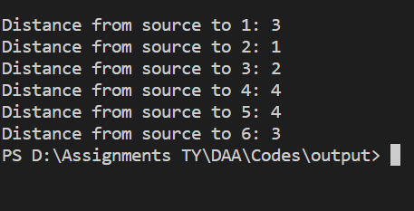

**Simulation:**

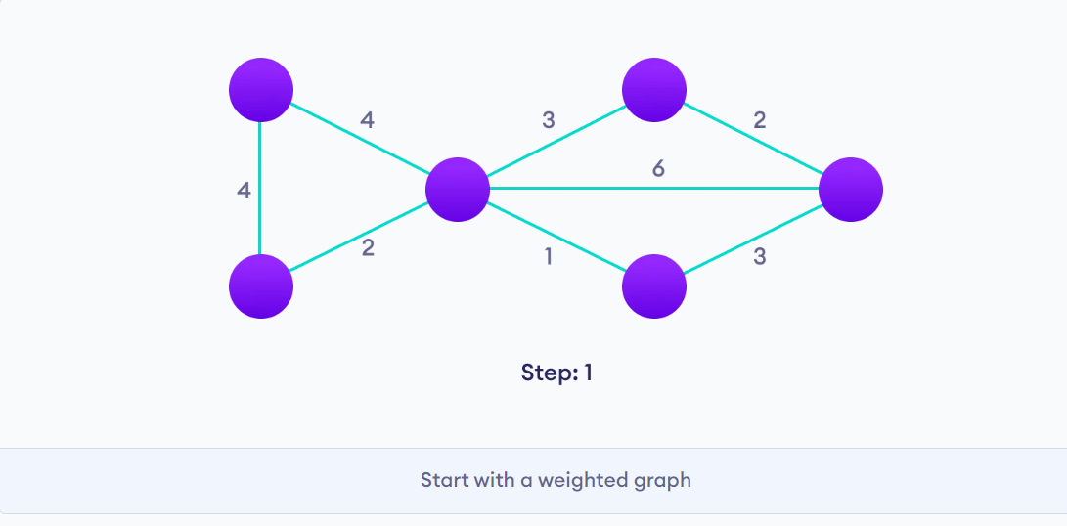 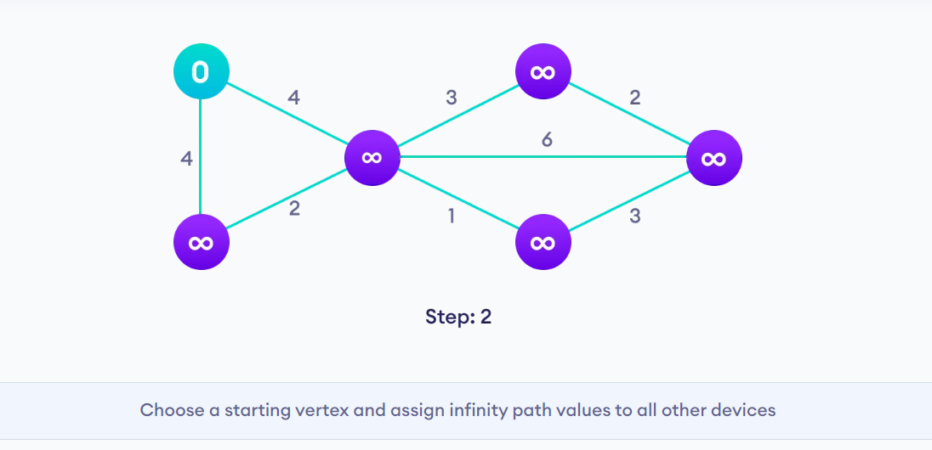 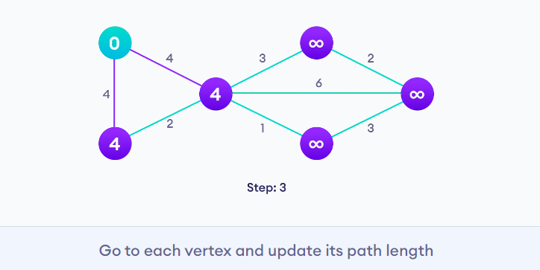 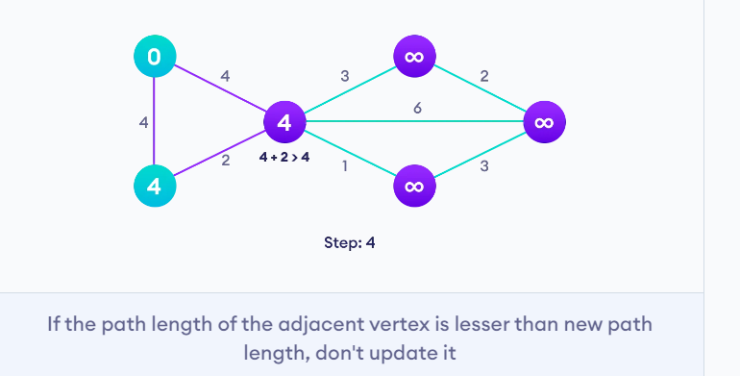 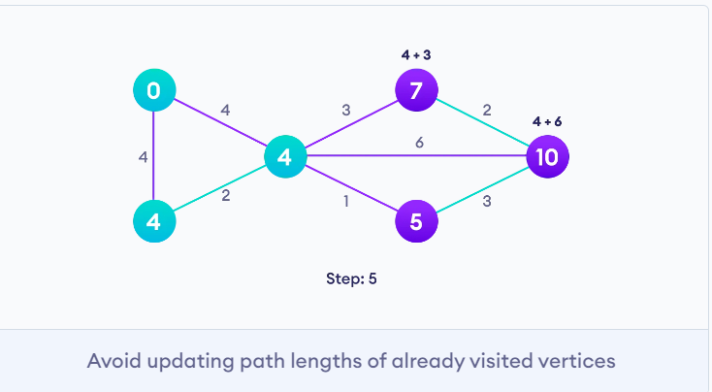 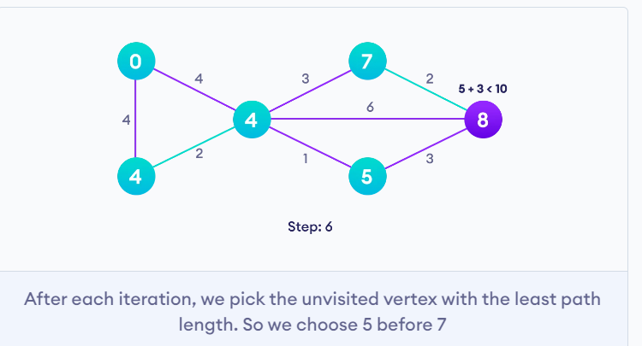 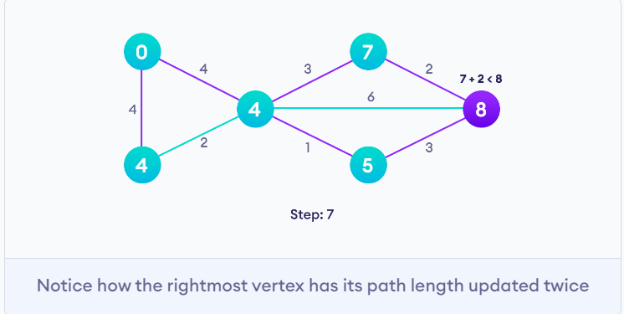 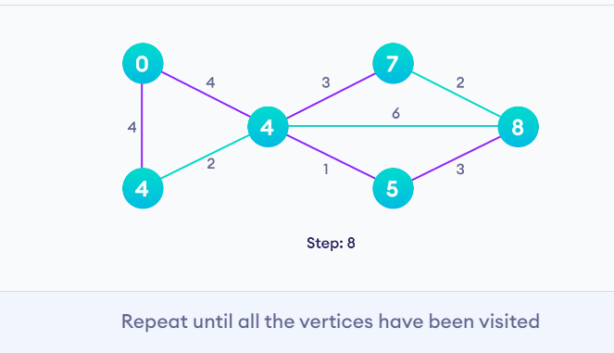

# 2) Huffmen coding

# Code:-

# // 2020BIT011

# #include <stdio.h>

# #include <stdlib.h>

# #define MAX_TREE_HT 50

# struct MinHNode {

# char item;

# unsigned freq;

# struct MinHNode *left, *right;

# };

# struct MinHeap {

# unsigned size;

# unsigned capacity;

# struct MinHNode **array;

# };

# struct MinHNode *newNode(char item, unsigned freq) {

# struct MinHNode *temp = (struct MinHNode *)malloc(sizeof(struct MinHNode));

# temp->left = temp->right = NULL;

# temp->item = item;

# temp->freq = freq;

# return temp;

# }

# struct MinHeap *createMinH(unsigned capacity) {

# struct MinHeap *minHeap = (struct MinHeap *)malloc(sizeof(struct MinHeap));

# minHeap->size = 0;

# minHeap->capacity = capacity;

# minHeap->array = (struct MinHNode **)malloc(minHeap->capacity * sizeof(struct MinHNode *));

# return minHeap;

# }

# void swapMinHNode(struct MinHNode **a, struct MinHNode **b) {

# struct MinHNode *t = *a;

# *a = *b;

# *b = t;

# }

# void minHeapify(struct MinHeap *minHeap, int idx) {

# int smallest = idx;

# int left = 2 * idx + 1;

# int right = 2 * idx + 2;

# if (left < minHeap->size && minHeap->array[left]->freq < minHeap->array[smallest]->freq)

# smallest = left;

# if (right < minHeap->size && minHeap->array[right]->freq < minHeap->array[smallest]->freq)

# smallest = right;

# if (smallest != idx) {

# swapMinHNode(&minHeap->array[smallest], &minHeap->array[idx]);

# minHeapify(minHeap, smallest);

# }

# }

# int checkSizeOne(struct MinHeap *minHeap) {

# return (minHeap->size == 1);

# }

# struct MinHNode *extractMin(struct MinHeap *minHeap) {

# struct MinHNode *temp = minHeap->array[0];

# minHeap->array[0] = minHeap->array[minHeap->size - 1];

# --minHeap->size;

# minHeapify(minHeap, 0);

# return temp;

# }

# void insertMinHeap(struct MinHeap *minHeap, struct MinHNode *minHeapNode) {

# ++minHeap->size;

# int i = minHeap->size - 1;

# while (i && minHeapNode->freq < minHeap->array[(i - 1) / 2]->freq) {

# minHeap->array[i] = minHeap->array[(i - 1) / 2];

# i = (i - 1) / 2;

# }

# minHeap->array[i] = minHeapNode;

# }

# void buildMinHeap(struct MinHeap *minHeap) {

# int n = minHeap->size - 1;

# int i;

# for (i = (n - 1) / 2; i >= 0; --i)

# minHeapify(minHeap, i);

# }

# int isLeaf(struct MinHNode *root) {

# return !(root->left) && !(root->right);

# }

# struct MinHeap *createAndBuildMinHeap(char item[], int freq[], int size) {

# struct MinHeap *minHeap = createMinH(size);

# for (int i = 0; i < size; ++i)

# minHeap->array[i] = newNode(item[i], freq[i]);

# minHeap->size = size;

# buildMinHeap(minHeap);

# return minHeap;

# }

# struct MinHNode *buildHuffmanTree(char item[], int freq[], int size) {

# struct MinHNode *left, *right, *top;

# struct MinHeap *minHeap = createAndBuildMinHeap(item, freq, size);

# while (!checkSizeOne(minHeap)) {

# left = extractMin(minHeap);

# right = extractMin(minHeap);

# top = newNode('$', left->freq + right->freq);

# top->left = left;

# top->right = right;

# insertMinHeap(minHeap, top);

# }

# return extractMin(minHeap);

# }

# void printHCodes(struct MinHNode *root, int arr[], int top) {

# if (root->left) {

# arr[top] = 0;

# printHCodes(root->left, arr, top + 1);

# }

# if (root->right) {

# arr[top] = 1;

# printHCodes(root->right, arr, top + 1);

# }

# if (isLeaf(root)) {

# printf(" %c | ", root->item);

# printArray(arr, top);

# }

# }

# void HuffmanCodes(char item[], int freq[], int size) {

# struct MinHNode *root = buildHuffmanTree(item, freq, size);

# int arr[MAX_TREE_HT], top = 0;

# printHCodes(root, arr, top);

# }

# void printArray(int arr[], int n) {

# int i;

# for (i = 0; i < n; ++i)

# printf("%d", arr[i]);

# printf("\n");

# }

# int main() {

# char arr[] = {'A', 'B', 'C', 'D'};

# int freq[] = {5, 1, 6, 3};

# int size = sizeof(arr) / sizeof(arr[0]);

# printf(" Char | Huffman code ");

# printf("\n--------------------\n");

# HuffmanCodes(arr, freq, size);

# }**Output:**

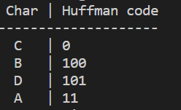

**Simulation:**

 